369ai
H R S U I T E F O R O D O O 1 9
HR LEAVE REQUEST
HR Step-by-Step Guide

Leave requests with manager approval, a paid-leave quota and automatic unpaid deductions.
A simple guide to setting the leave policy, raising a request, approving it and reading the balance.
Module Version 19.0.1.1.0 · Odoo 19 · Human Resources
About This Module
HR Leave Request gives every employee a simple way to ask for time off and gives managers a clear way to approve it. Beyond a yes/no, the module understands your paid-leave policy: it tracks how much paid leave each person has left, splits a request into paid and unpaid days when the quota runs out, and works out the salary deduction for the unpaid part automatically.
This guide follows a request end to end: configure the policy once, raise a request, approve or reject it, and read the balance and reports.
What the Module Gives You at a Glance
- Simple requests — from date, optional to date, half-day option and a reason.
- Six leave types — Sick, Casual, Annual, Personal, Emergency and Other.
- A clear lifecycle — Draft, Pending Approval, Approved, Rejected and Cancelled.
- Paid-leave quota — configurable per year and per month.
- Automatic paid/unpaid split — when the quota is exceeded.
- Automatic deductions — salary deduction for unpaid days.
- Per-employee balance — used and remaining at a glance.
- Overlap protection — two requests cannot cover the same dates.
- Carry-forward — optional carry-over of unused paid leave to next year.

Who this is for: Employees who raise requests, Managers who approve them, and HR Administrators who set the company leave policy and quotas.

PART 1 FINDING LEAVE REQUESTS

1 | Open the Leave Requests menu

Everything lives under Attendances → Leave Requests. Employees use My Leave Requests; managers also see All Leave Requests and the Approved Leaves Report. The policy sits under Configuration → Leave Policy.
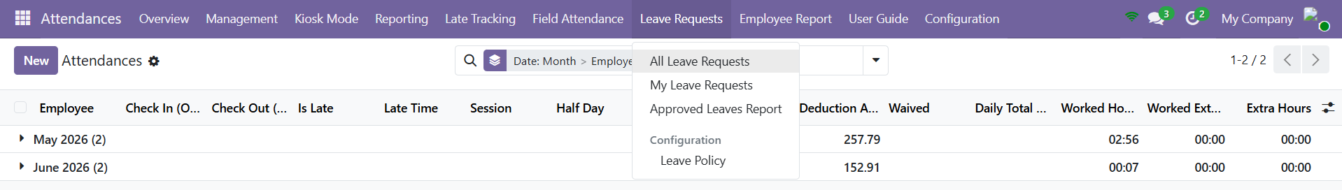
The Leave Requests menu under Attendances, with the Configuration → Leave Policy entry.

PART 2 CONFIGURING THE LEAVE POLICY

The policy is set once per company and drives every calculation that follows.
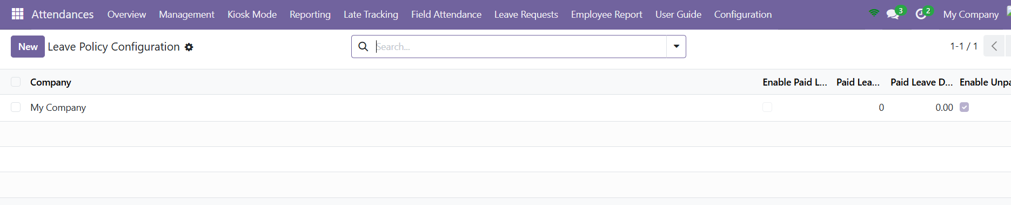
Configuration → Leave Policy lists the leave policy held for each company.
2 | Set the paid-leave settings

Open Configuration → Leave Policy. Turn on Enable Paid Leave and set Paid Leave Days Per Year and Paid Leave Days Per Month. These define how much leave is paid before deductions begin.
3 | Set the unpaid / deduction settings

Turn on Enable Unpaid Leave Deduction so that days beyond the quota are deducted. The deduction uses the employee's monthly wage divided by the working days in the month; a half day is half of that daily rate.
4 | Set carry-forward (optional)

Enable Allow Carry Forward and set Max Carry Forward Days if unused paid leave should roll over to next year.
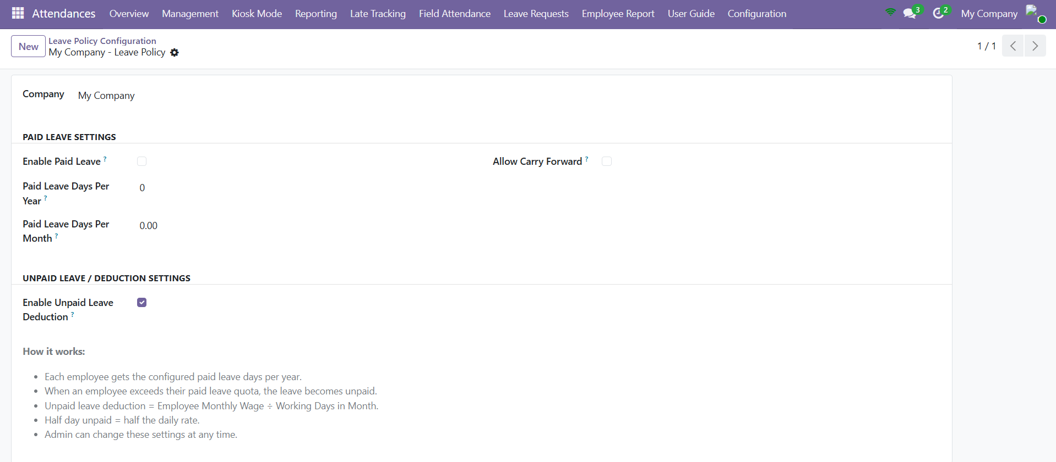
The Leave Policy form — paid-leave settings, unpaid-deduction settings and how the deduction is worked out.
NOTE Paid days are limited by the smaller of the yearly and monthly remaining quota. Anything above that becomes unpaid and is deducted automatically.

PART 3 RAISING A LEAVE REQUEST

This part is for employees. Open Attendances → Leave Requests → My Leave Requests.
5 | Fill in the request

Click New and complete the form: confirm your Employee, choose a Leave Type (Casual is the default), set the From Date (required) and, for more than one day, a To Date. Tick Half Day for a half-day request, and add a Reason.
Leave type | Typical use
Sick Leave | Illness or medical appointments.
Casual Leave | Short, planned personal time off (the default).
Annual Leave | Planned holiday / vacation.
Personal Leave | Personal matters not covered above.
Emergency Leave | Urgent, unforeseen situations.
Other | Anything that does not fit the categories above.

As you fill the dates the form shows Number of Days, and once saved it splits them into Paid Days and Unpaid Days with the matching Deduction Amount.
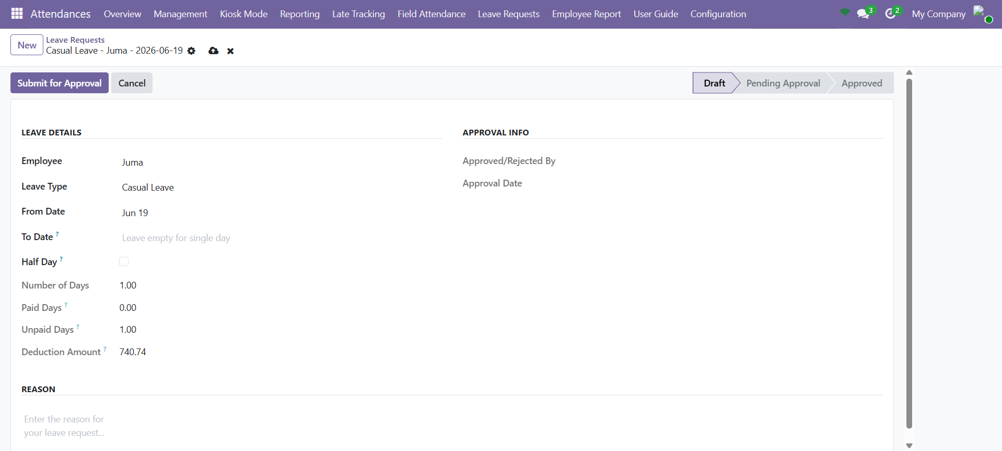
A new leave request in Draft, showing the number of days and the paid / unpaid split.
6 | Submit for approval

Click Submit for Approval. The request moves from Draft to Pending Approval and waits for a manager. You can Cancel a request, and a rejected or cancelled one can be reset to Draft and resubmitted.
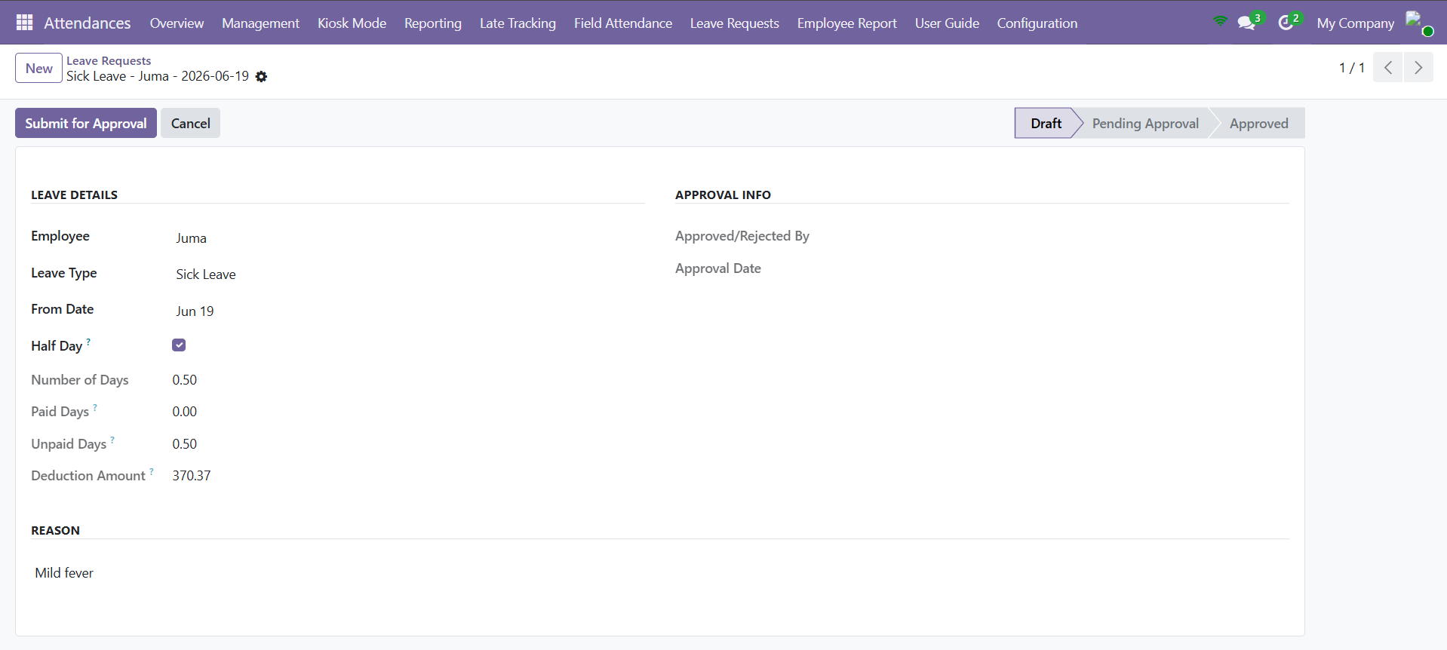
A completed request ready to Submit for Approval (a half-day Sick Leave example).
IMPORTANT Requests cannot overlap. If your dates clash with an existing non-rejected request, the system blocks it and tells you which request it conflicts with.

PART 4 APPROVING REQUESTS

7 | Review and decide (manager)

Open All Leave Requests — it opens pre-filtered to Pending. Open a request, check the dates, type, paid/unpaid split and reason, then click Approve or Reject. Rejecting lets you add a Rejection Reason that the employee will see.
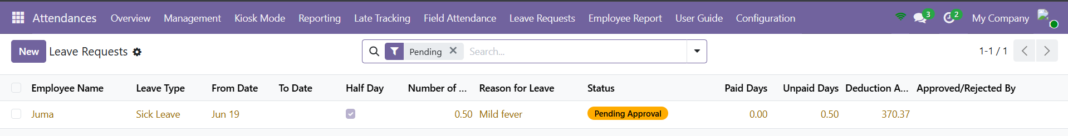
All Leave Requests, pre-filtered to Pending and waiting on a manager.
State | Meaning | Who acts / button
Draft | Being prepared. | Employee — Submit for Approval
Pending Approval | Waiting on a manager. | Manager — Approve / Reject
Approved | Granted; paid/unpaid split fixed. | Employee — Cancel (if needed)
Rejected | Declined, with a reason. | Employee — Reset to Draft
Cancelled | Withdrawn. | Employee — Reset to Draft

PART 5 BALANCE & REPORTING

8 | Read the balance and reports

My Leave Requests lists your requests colour-coded by status (green approved, orange pending, red rejected, grey cancelled) with the paid, unpaid and deduction figures. Managers use the Approved Leaves Report, grouped by employee, for payroll and the leave calendar.
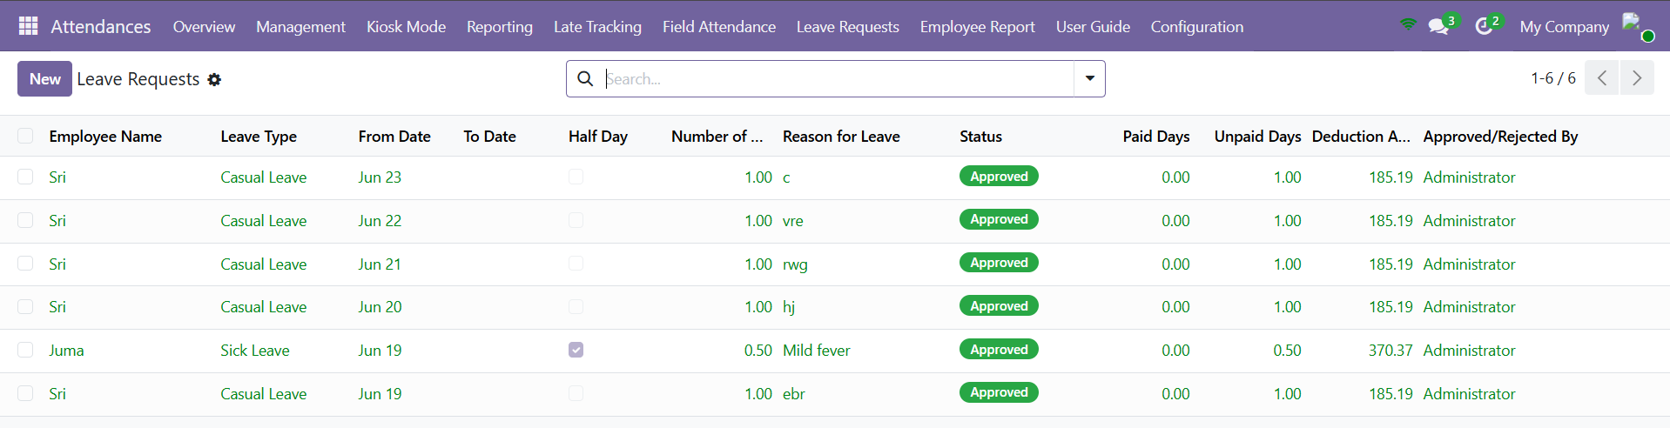
Requests are colour-coded by status, with the paid, unpaid and deduction figures.
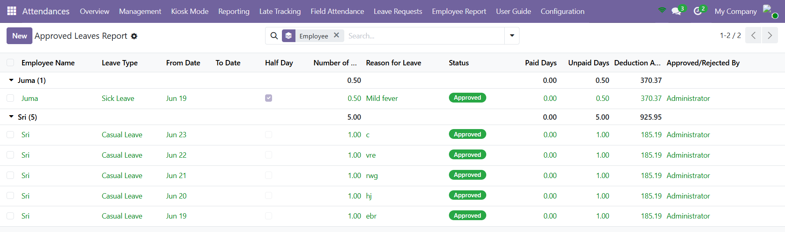
The Approved Leaves Report, grouped by employee, for payroll.
Quick Reference — Buttons & Menus
Where | What it does
Leave Policy | Set paid quota, unpaid deduction and carry-forward (admin).
My Leave Requests | Raise and track your own requests.
Submit for Approval | Send a draft request to your manager.
Approve / Reject | Manager decision on a pending request.
Cancel / Reset to Draft | Withdraw a request, or reopen a rejected/cancelled one.
All Leave Requests | Manager queue, pre-filtered to pending.
Approved Leaves Report | Approved leave grouped by employee for payroll.

Things to Remember
- Set the Leave Policy first — the paid/unpaid split and deductions depend on it.
- From Date is required; add a To Date for multi-day leave, or tick Half Day for half a day.
- Paid days follow your remaining yearly and monthly quota; the rest is unpaid and deducted.
- Requests cannot overlap an existing non-rejected request.
- Managers work from All Leave Requests (pending); Approved Leaves Report feeds payroll.

— End of Guide —
369ai.Biz | HR Leave Request — HR Guide

